Global Winds: Non Rotating Earth

One the following pictures, draw arrows to indicate the movement of air and explain why. First, indicate the hot and cold regions. Then, draw arrows that show how air moves. Then, using your knowledge of temperature, density and pressure, explain why.
1)
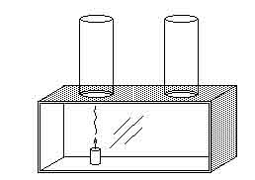
2)
3)
